Mason Buff, Liam Timoney

BUS 441 Assignment 4

**Network Design**

**Introduction:**

GenoMed Innovations stands at the forefront of the biotech industry, dedicated to leveraging cutting-edge genetic research to drive medical advancements. With a diverse team of 80 professionals, the company balances a dynamic work model—combining in-office collaboration with remote flexibility and on-site client engagements. This hybrid work environment necessitates a robust, secure, and versatile network infrastructure tailored to support high-throughput data analysis, uninterrupted virtual collaboration, and secure access to sensitive proprietary and customer information.

Assuming the recently renovated industrial space brings a blend of modern amenities and architectural challenges, the network design must account for potential signal impediments and leverage both wireless and wired technologies. It's also presumed that the structure's thick walls and mixed materials require strategic placement of access points and use of high-grade cabling to ensure optimal connectivity. Moreover, with plans for growth, the network must not only cater to the current headcount but also be scalable to accommodate additional personnel and technological advancements without extensive overhauls: There are storage rooms and plans for a future board room to help harbor predicted physical growth. As for the network, its backbone will thus be designed with an eye toward the future, ensuring GenoMed's infrastructure can evolve alongside its revolutionary work in biotechnology. Including a rental property to allow for additional revenue while continuing to scale the company.

**Network Diagram:**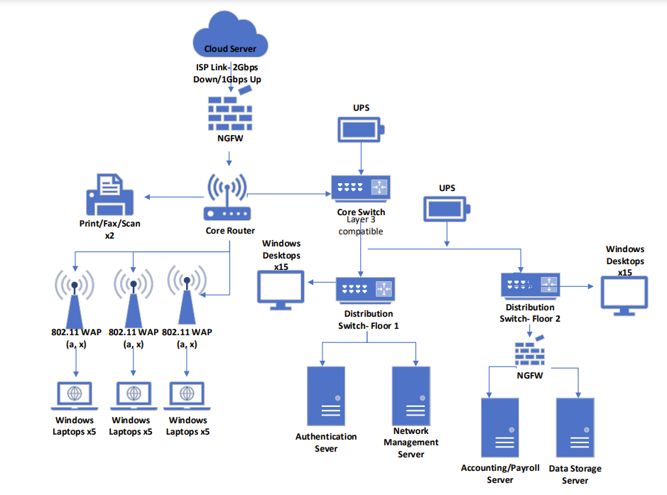

**Design Narrative:**

The network architecture for GenoMed Innovations has been meticulously architected to align with the company’s critical requirements for speed, security, and reliability, while also providing the flexibility to support a growing, dynamic workforce. The proposed design employs a hybrid model, integrating both wired and wireless solutions to ensure comprehensive coverage and connectivity throughout the company's two-floor facility.

For the wired infrastructure, we've selected 100 Base-TX Cat6A cabling, supporting data transmission speeds up to 10 Gbps over 100 meters. This choice not only satisfies the current 1 Gbps requirement but also anticipates future bandwidth needs, ensuring a sustainable investment. The backbone of the wired network is a Layer 3 Core Switch, which facilitates inter-VLAN routing necessary for network segmentation—a vital strategy for enhancing performance and security.

Wireless connectivity is provided via Wi-Fi 6 (802.11ax) technology, chosen for its superior data throughput of up to 9.6 Gbps and improved efficiency in high-density scenarios. Wi-Fi 6's technologies allow multiple users to simultaneously receive data without congestion, a crucial feature for GenoMed's collaborative environment where large data packets are frequently exchanged.

Security is woven into the fabric of the network's design. At the perimeter, a Next-Gen Firewall provides comprehensive threat prevention capabilities, including deep packet inspection, intrusion prevention, and advanced visibility into encrypted traffic. Internally, network segmentation via VLANs isolates sensitive data flows, such as confidential research data and payroll, from general office traffic, mitigating the risk of lateral movement should a breach occur.

Each server's role has been carefully considered. The authentication server employs Active Directory services to manage user credentials and access policies, pivotal for both in-house and remote staff. A dedicated network management server allows centralized control and monitoring, ensuring optimal network performance and quick response to any issues. The accounting/payroll and confidential data storage servers are positioned behind a secondary firewall for an additional layer of protection, acknowledging the sensitive nature of the information they contain.

Furthermore, wireless access points are distributed strategically to maximize coverage and minimize interference, a critical consideration given the unknown building materials that could potentially hinder signal propagation. With the inclusion of Uninterruptible Power Supplies (UPS), the network's core components are safeguarded against data loss due to power outages, bolstering operational continuity.

In sum, the chosen network specifications and standards reflect a balance between current needs and forward-looking growth, ensuring that GenoMed Innovations' network remains robust, secure, and adaptable in the face of evolving technological landscapes.

**Network Floor Plan:**

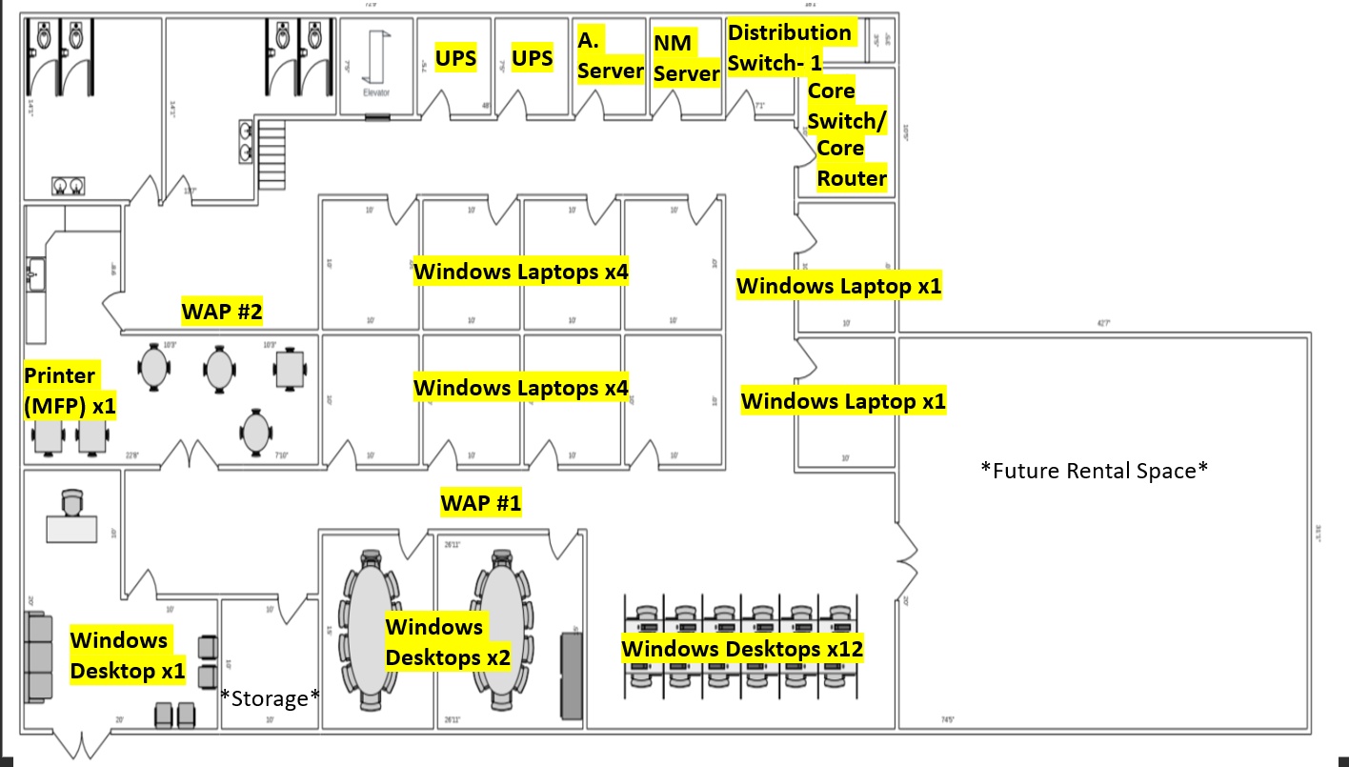

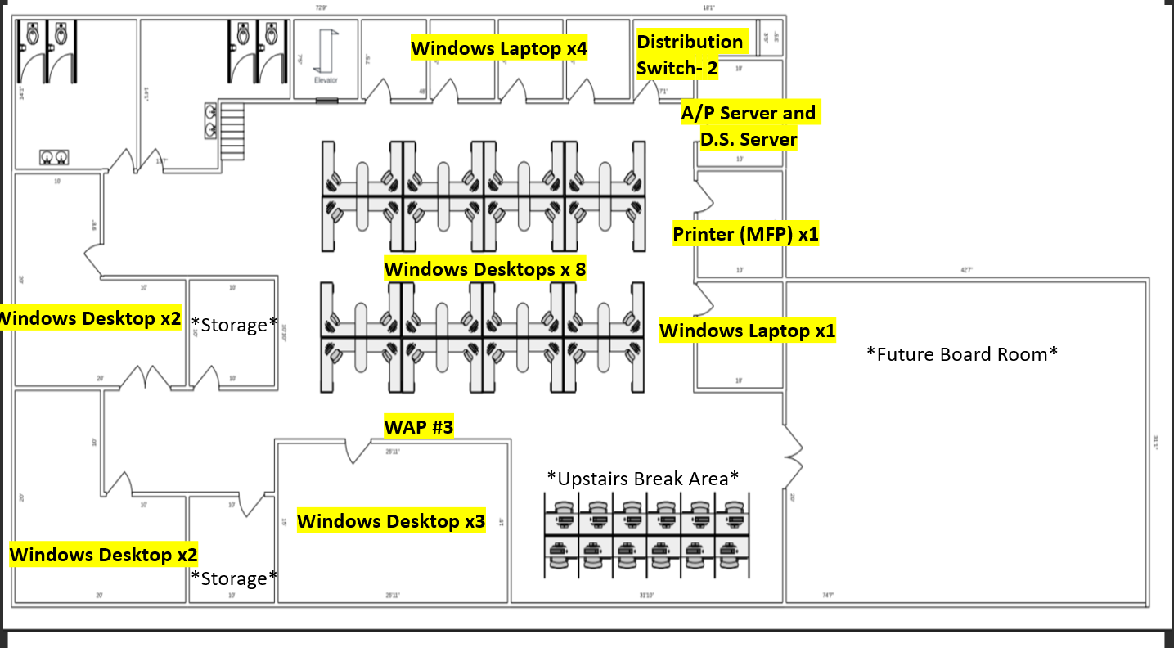

**Proposed Products and Cost:**

**Servers**

* Vendor/Product: Dell PowerEdge R740 Server
* Technical Capabilities: A robust server platform offering scalable storage, high memory density, and multiple I/O options designed for complex workloads.
* Justification: Supports GenoMed's computational demands for genome sequencing and research data analysis while providing scalability for future growth.
* Estimated Cost: ~$2,500-$4,000 per unit
* Product Link:

<https://www.dell.com/en-us/shop/dell-poweredge-servers/poweredge-r740-rack-server/spd/poweredge-r740/pe_r740_tm_vi_vp_sb>

**Switches**

* Vendor/Product: Cisco Catalyst 9300 Series Switches
* Technical Capabilities: Industry-leading switches offering high-speed data handling, advanced security, and comprehensive network control with Layer 2 and Layer 3 features.
* Justification: Reliable and secure data management across GenoMed's extensive network infrastructure, supporting both current and future networking demands.
* Estimated Cost: ~$5,000-$8,000 per unit
* Product Link:

<https://www.cisco.com/c/en_hk/products/switches/catalyst-9300-series-switches/index.html>

**Routers**

* Vendor/Product: Cisco 4000 Series Integrated Services Routers
* Technical Capabilities: Modular routers that support diverse connectivity options, including LAN and WAN interfaces, with a suite of integrated network services.
* Justification: Allows GenoMed to tailor their networking environment to their specific needs while ensuring secure, reliable connectivity.
* Estimated Cost: ~$1,500-$3,000 per unit
* Product Link: <https://www.cisco.com/c/en/us/products/routers/4000-series-integrated-services-routers-isr/index.html>

**Wireless Access Points**

* Vendor/Product: Aruba 530 Series Wireless Access Points
* Technical Capabilities: High-efficiency Wi-Fi 6 access points designed for high-density environments, supporting IoT and mobile devices seamlessly.
* Justification: Meets the wireless communication needs of GenoMed's staff within the office and remote settings, ensuring high-speed and reliable access.
* Estimated Cost: ~$700-$1,000 per unit
* Product Link: <https://www.arubanetworks.com/products/wireless/access-points/indoor-access-points/530-series/>

**Firewalls**

* Vendor/Product: Fortinet FortiGate 600E
* Technical Capabilities: This NGFW is equipped with high-performance CPUs to provide security and deep packet inspection without compromising network speed.
* Justification: The FortiGate 600E's ability to manage high volumes of traffic without latency is ideal for GenoMed's need to protect and quickly process large data sets securely.
* Estimated Cost: ~$8,000-$12,000 per unit
* Product Link:

<https://www.avfirewalls.com/FortiGate-600E.asp>

**Uninterruptible Power Supplies (UPS)**

* Vendor/Product: APC Smart-UPS SRT 5000VA
* Technical Capabilities: Offers battery backup, surge protection, and prolonged runtime for critical electronics, maintaining power stability.
* Justification: Essential for preventing data loss and ensuring continuity of GenoMed’s operations during power outages, especially in lab environments where experiments may be sensitive to power fluctuations.
* Estimated Cost: ~$3,000-$6,000 per unit
* Product Link:

<https://www.apc.com/us/en/product/SRT5KRMXLT/apc-smartups-online-5-4kva-rackmount-3u-208v-2x-l620r+2x-l630r-nema-outlets-network-card+smartslot-extended-runtime-w-rail-kit/>

**Networked Multifunction Printers (MFPs)**

* Vendor/Product: HP LaserJet Enterprise MFP M528 series
* Technical Capabilities: A reliable MFP that provides secure printing, scanning, and faxing, equipped with features to protect against firmware attacks.
* Justification: The security features of the HP MFP ensure that GenoMed’s sensitive documents are handled safely, aligning with the company’s strict data protection policies.
* Estimated Cost: ~$1,200-$2,000 per unit
* Product Link: <https://support.hp.com/us-en/product/details/hp-laserjet-enterprise-mfp-m528-series/19390468>

**Endpoint Security Software**

* Vendor/Product: Symantec Endpoint Protection
* Technical Capabilities: Advanced protection for endpoints against malware, zero-day threats, and sophisticated attacks.
* Justification: Protects GenoMed's data and intellectual property from endpoint vulnerabilities, which is critical for maintaining the integrity of their research.
* Estimated Cost: ~$40-$60 per endpoint/year
* Product Link:

<https://www.broadcom.com/support/security-center/definitions/download/detail?gid=sep14>

**Network Management Software**

* Vendor/Product: SolarWinds Network Performance Monitor
* Technical Capabilities: Comprehensive network monitoring tool that provides visibility into network performance, fault diagnosis, and availability.
* Justification: Enables proactive management of GenoMed’s network, ensuring high availability and performance, which are vital for their time-sensitive research.
* Estimated Cost: ~$2,995 for up to 100 elements
* Product Link:

<https://www.solarwinds.com/network-performance-monitor>

**Networking Cables (Wired Infrastructure)**

* Vendor/Product: Bulk Cat6A Ethernet Cable
* Technical Capabilities: Supports bandwidths up to 10 Gbps with a maximum length of 100 meters, suitable for in-building data transfer.
* Justification: The chosen cabling will support GenoMed's current and near-future bandwidth requirements, avoiding the need for re-cabling as part of an upcoming expansion or technology update.
* Estimated Cost: ~$200-$300 per 1000 ft roll
* Product Link:

<https://www.monoprice.com/product?p_id=13071&utm_term=&utm_campaign=PMax:+Smart+Shopping+-+Monoprice+-+Cables&utm_source=google&utm_medium=cpc&hsa_acc=6614305189&hsa_cam=17490724715&hsa_grp=&hsa_ad=&hsa_src=x&hsa_tgt=&hsa_kw=&hsa_mt=&hsa_net=adwords&hsa_ver=3&gad_source=1&gclid=CjwKCAiAvJarBhA1EiwAGgZl0Gr62T2ZT2pgU_eq2nnaqWgpHfYHCERKf3FImaMtfnUENu9WB0LJSRoCUHcQAvD_BwE>

### **Cable Management**

* Vendor/Product: StarTech.com Cable Trays and Conduits
* Technical Capabilities: Metal structure to securely guide and organize cables throughout the building.
* Justification: Helps maintain an organized and safe network infrastructure, crucial in a facility with complex cabling needs.
* Estimated Cost: ~$50-$100 per tray/conduit
* Product Link:

<https://www.startech.com/en-us/cables/udcmtray>

### **Patch Panels**

* Vendor/Product: TRENDnet 48-Port Cat6A Unshielded Wallmount or Rackmount Patch Panel
* Technical Capabilities: Accommodates 48 Ethernet connections, compatible with Cat6A performance standards.
* Justification: Simplifies the cabling infrastructure, making it easier to manage and troubleshoot.
* Estimated Cost: ~$100-$150 per panel
* Product Link:

<https://www.trendnet.com/products/patch-panels/TC-P48C6>

### **Network Racks**

* Vendor/Product: Tripp Lite 42U Server Rack Enclosure
* Technical Capabilities: 42U rack space with locking doors and side panels for secure, organized server and network equipment storage.
* Justification: Protects valuable network equipment and provides a central point for all network operations.
* Estimated Cost: ~$1,000-$1,500 per rack
* Product Link: <https://tripplite.eaton.com/42u-smartrack-standard-depth-server-rack-enclosure-cabinet-doors-side-panels~SR42UB>

### **Wall Plates and Connectors**

* Vendor/Product: Cable Matters 10-Pack Low Profile 2-Port Keystone Jack Wall Plate
* Technical Capabilities: Provides a clean, organized interface for Ethernet cable connections using Cat6A keystone jacks.
* Justification: Allows for easy access and connectivity for wired workstations, contributing to an orderly and functional network setup.
* Estimated Cost: ~$5-$10 per wall plate and jack
* Product Link: <https://www.amazon.com/Cable-Matters-Listed-2-Port-Keystone/dp/B0072JVU8S>

### **Wireless Controllers**

* Vendor/Product: Cisco 3504 Wireless Controller
* Technical Capabilities: Supports up to 150 access points and 3000 clients, ideal for enterprise-level networks.
* Justification: Essential for managing a large-scale Wi-Fi network, providing centralized control and real-time wireless communication adjustments.
* Estimated Cost: ~$1,000-$5,000 depending on the model and capacity
* Product Link: <https://www.cisco.com/c/en/us/support/wireless/3504-wireless-controller/model.html>